**Lab Practical #08:**

Implement the various network protocols - DHCP

**Practical Assignment #08:**

Implement the application protocol - DHCP using packet tracer.

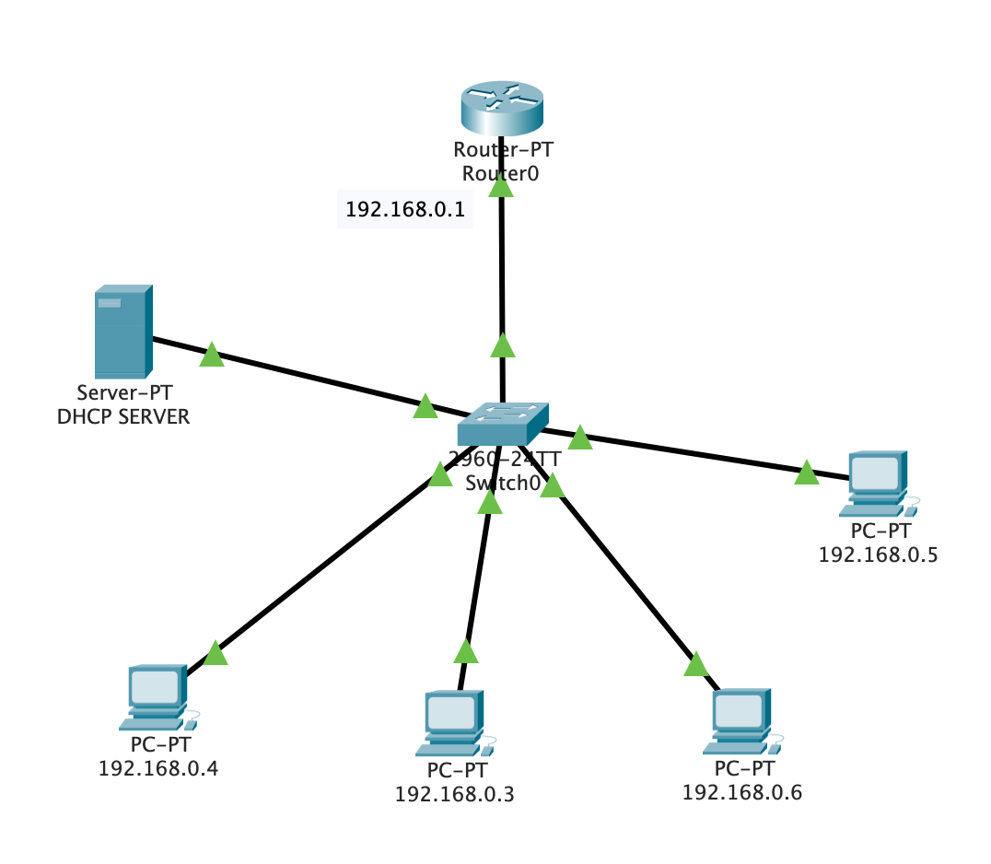

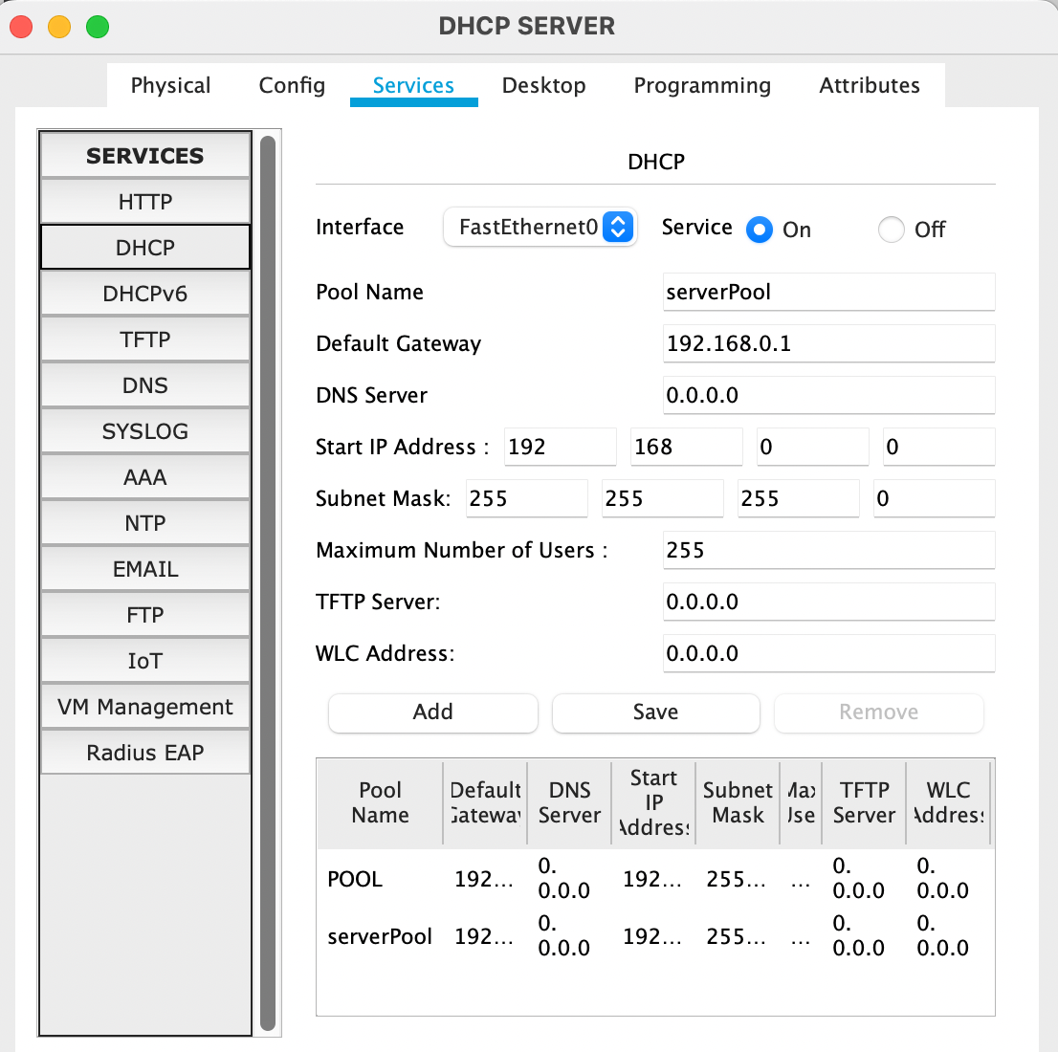

DHCP Configuration

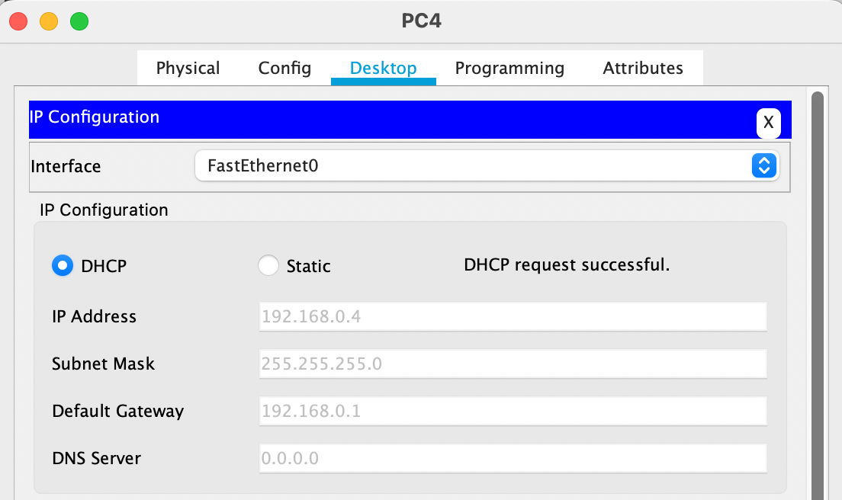

Automatic IP, subnet mask & Default Getway Assign

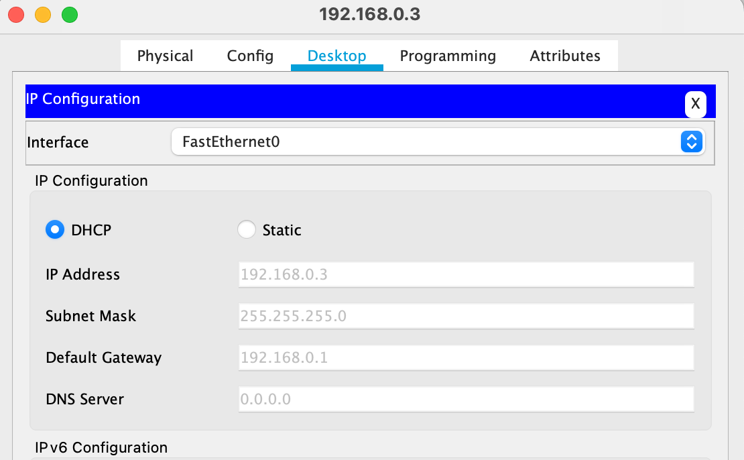

Automatic IP, subnet mask & Default Getway Assign

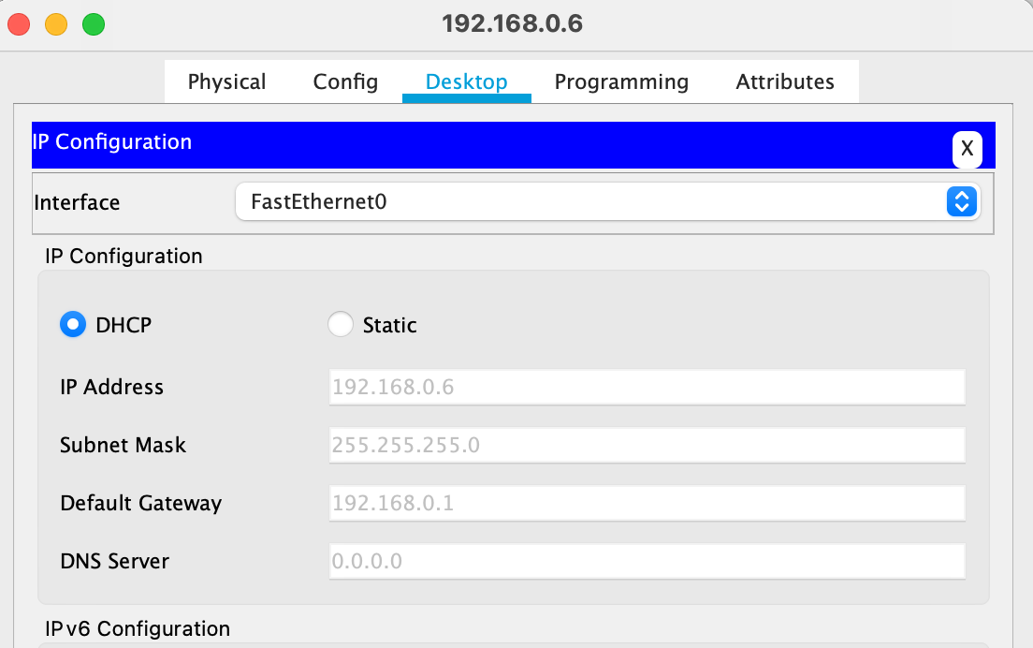

Automatic IP, subnet mask & Default Getway Assign

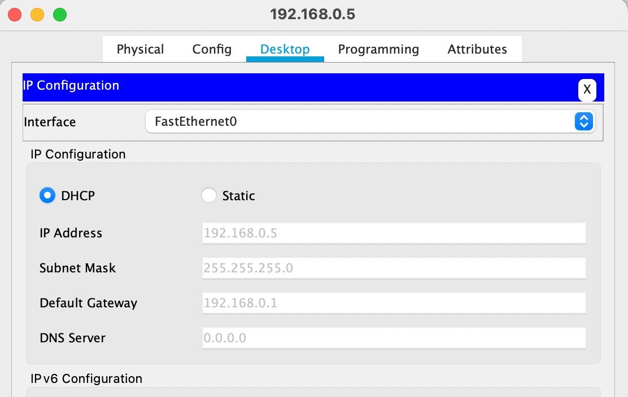

Automatic IP, subnet mask & Default Getway Assign

Ping from 192.168.0.4 to 192.168.0.5